|  |  |  |  |
| --- | --- | --- | --- |
| |  |  |  | | --- | --- | --- | | |  |  | | --- | --- | | |  | | --- | | **Internal Incident: 1870390242, BP name not displayed in print form after**  **changing the deviating address** | | | |

In case of a print preview from the forwarding settlement, CL_TM_INVOICE=>get_data_from_buffer is called.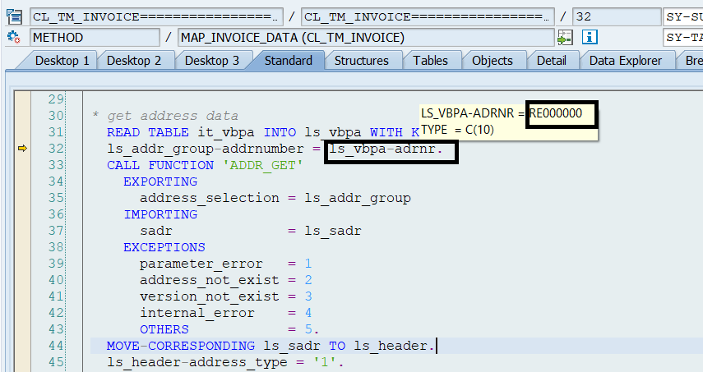

Since ls_vbpa-adnr does not contain a valid address number, ls_sadr will be empty.

Adrnr

Anred

Name1

Psltz

Ort01

Land1

Sortl

Spras

Regio

C5v: fwo 44831

Fwsd 27047